**Name :** Haricharan Bharathi

**Reg. No:** 205001043

**Date: 16-11-23**

**Topic: App to display a Web Page**

**Exercise No. : 12**

**Aim :** Develop a Menu driven App that displays the option menu that contains names of different countires and when each of the country is clicked, the description about the country should be displayed.

**Code :**

MainActivity.java:

package com.example.webpage;

import androidx.appcompat.app.AppCompatActivity;

import android.os.Bundle;

import android.view.View;

import android.webkit.WebView;

import android.webkit.WebViewClient;

import android.widget.Button;

import android.widget.EditText;

public class MainActivity extends AppCompatActivity {

private WebView webView;

private EditText url;

private Button getButton;

@Override

protected void onCreate(Bundle savedInstanceState) {

super.onCreate(savedInstanceState);

setContentView(R.layout.activity_main);

webView = findViewById(R.id.webView);

url = findViewById(R.id.url);

getButton = findViewById(R.id.load);

webView.getSettings().setJavaScriptEnabled(true);

// Load static HTML content

String staticHtml = "<html>\n" +

"<body>\n" +

"\n" +

"<h1 style=\"color:red; font-family:sans-serif\">This is a HTML" +

"Site</h1>\n" +

"\n" +

"<p style=\"color:red;\">A red paragraph.</p>\n" +

"\n" +

"<h2>An Unordered HTML List</h2>\n" +

"\n" +

"<ul>\n" +

" <li>MAD lab</li>\n" +

" <li>GML lab</li>\n" +

" <li>SNA lab</li>\n" +

"</ul>\n" +

"\n" +

"</body>\n" +

"</html>";

webView.loadData(staticHtml, "text/html", "UTF-8");

webView.setWebViewClient(new WebViewClient()

{

@Override

public boolean shouldOverrideUrlLoading(WebView view, String url)

{

//view.loadUrl(url);

System.out.println("hello");

return false;

}

});

getButton.setOnClickListener(new View.OnClickListener() {

@Override

public void onClick(View v) {

webView.loadUrl("https://" + url.getText().toString());

}

});

}

}

activity_main.xml

<?xml version="1.0" encoding="utf-8"?>

<LinearLayout xmlns:android="http://schemas.android.com/apk/res/android"

xmlns:app="http://schemas.android.com/apk/res-auto"

xmlns:tools="http://schemas.android.com/tools"

android:layout_width="match_parent"

android:layout_height="match_parent"

android:padding="10dp"

tools:context=".MainActivity">

<LinearLayout

android:layout_width="match_parent"

android:layout_height="match_parent"

android:orientation="vertical">

<LinearLayout

android:layout_width="match_parent"

android:layout_height="wrap_content"

android:orientation="horizontal">

<TextView

android:id="@+id/textView"

android:layout_width="60dp"

android:layout_height="wrap_content"

android:paddingBottom="10dp"

android:paddingLeft="15dp"

android:textStyle="bold"

android:text="URL:" />

<EditText

android:id="@+id/url"

android:layout_width="237dp"

android:layout_height="wrap_content"

android:layout_weight="1"

android:ems="10"

android:inputType="text" />

<Button

android:id="@+id/load"

android:layout_width="wrap_content"

android:layout_height="wrap_content"

android:layout_weight="1"

android:text="GET" />

</LinearLayout>

<WebView

android:id="@+id/webView"

android:layout_width="match_parent"

android:layout_height="match_parent">

</WebView>

</LinearLayout>

</LinearLayout>

**Output :**

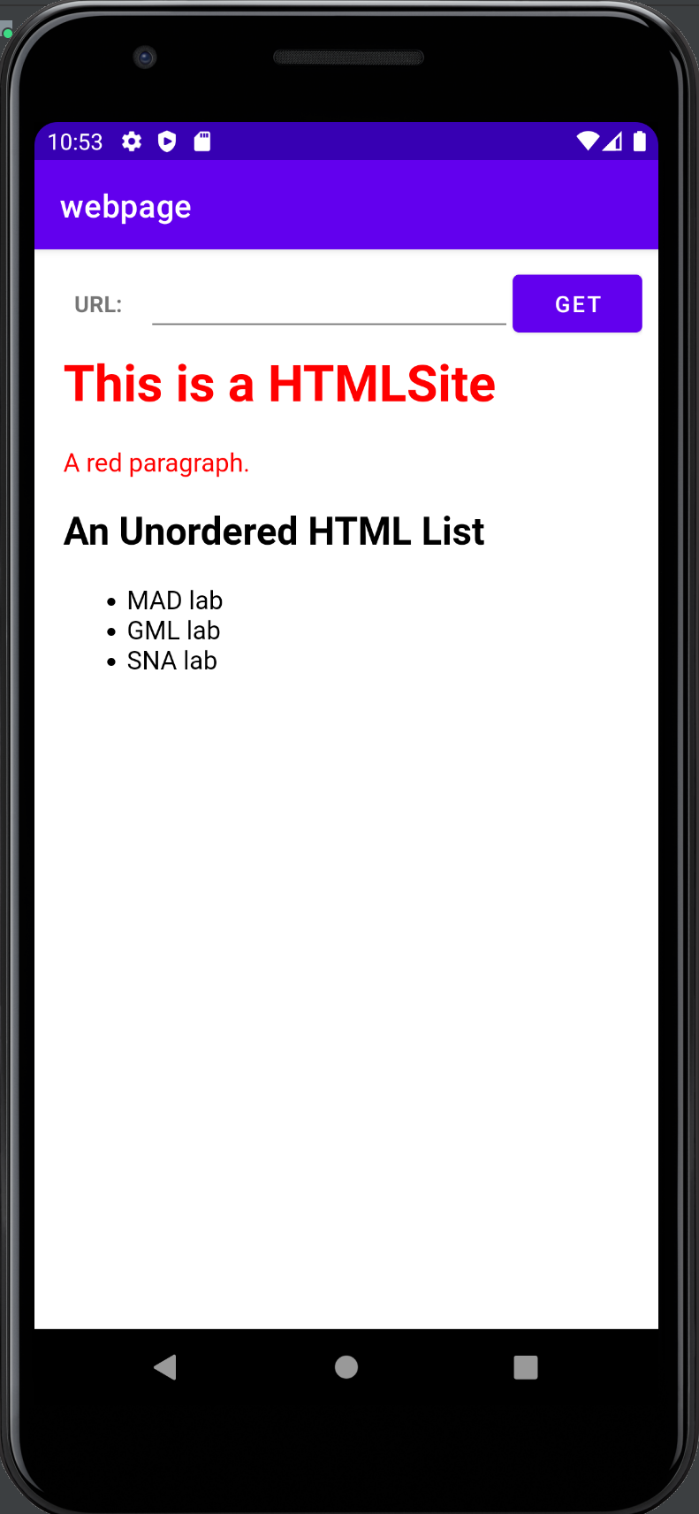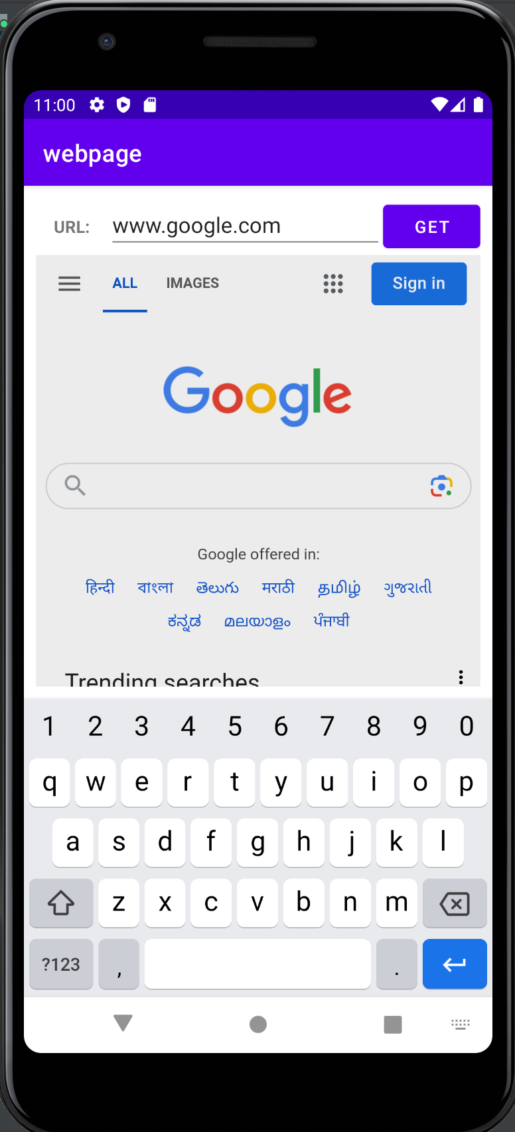

**Learning Outcome :**

1. Learnt to access internet
2. Learnt how to parse URLs